
K.R. MANGALAM UNIVERSITY
BACHELOR OF TECHNOLOGY
COMPUTER SCIENCE AND ENGINEERING

WEB PROGRAMMING WITH PYTHON AND JAVASCRIPT LAB
SEC035

LAB PRACTICALS

SUBMITTED BY :

NAME : ARYAN MISHRA
BTECH CSE CORE
SEMESTER : IV
SECTION : B
ROLL : 2401010304

SUBMITTED TO :

MS. MANSI KAJAL MAM

EXPERIMENT – IV

Aim:
To develop a Contact Management System using Flask (Python) that demonstrates CRUD operations, in-memory data storage, routing, template rendering, and form handling.
Tasks Performed:
- Created project folder named contact_manager
- Created and linked files: app.py, base.html, index.html, add_contact.html, edit_contact.html
- Designed Flask application with in-memory list as database
- Implemented index route to display all contacts with search functionality
- Built Add Contact form with POST method handling
- Implemented Edit Contact route with pre-filled form values
- Added Delete Contact route with list filtering
- Applied CSS styling in base.html with purple gradient theme
- Used Jinja2 template inheritance with {% extends %} and {% block %}
- Implemented search by name or phone number

Tech Stack Used:

app.py (Flask Backend – Part 1):

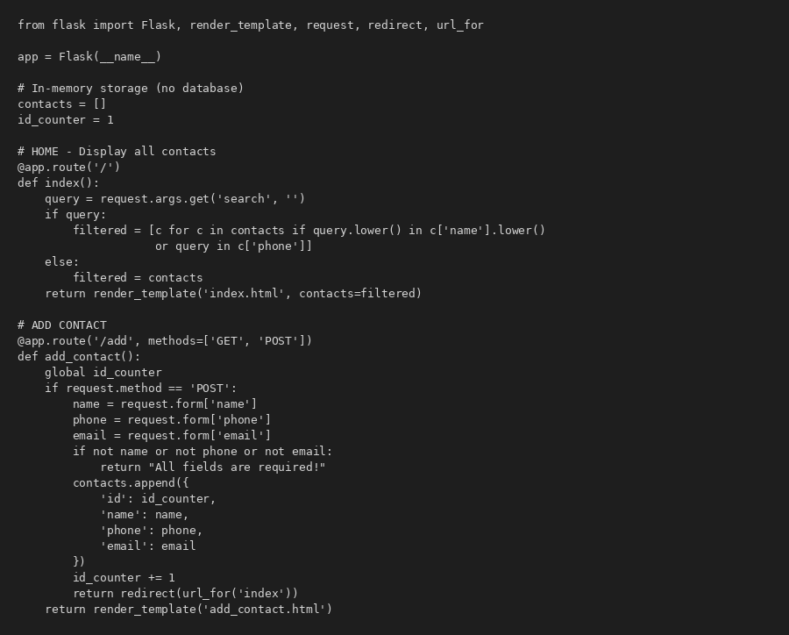

app.py (Flask Backend – Part 2):

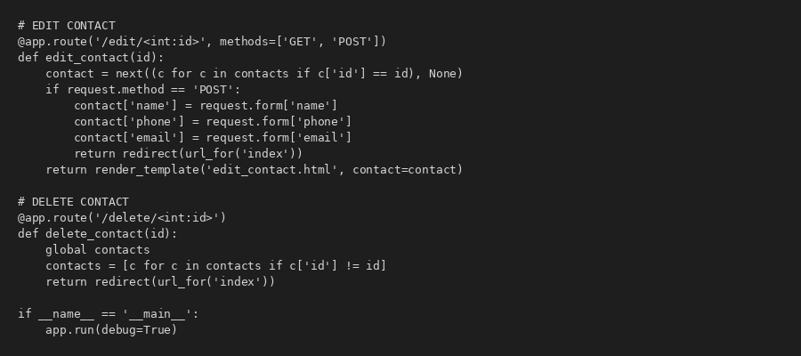

base.html (Base Template with CSS):

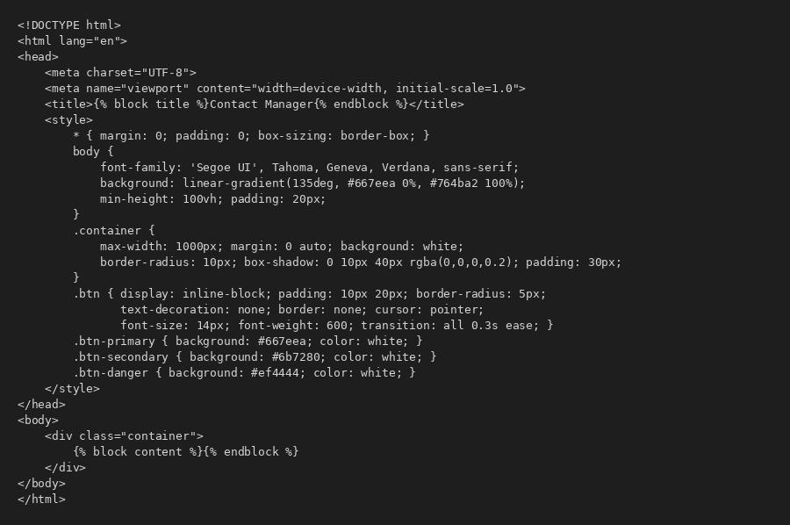

index.html (Home Page – List All Contacts):

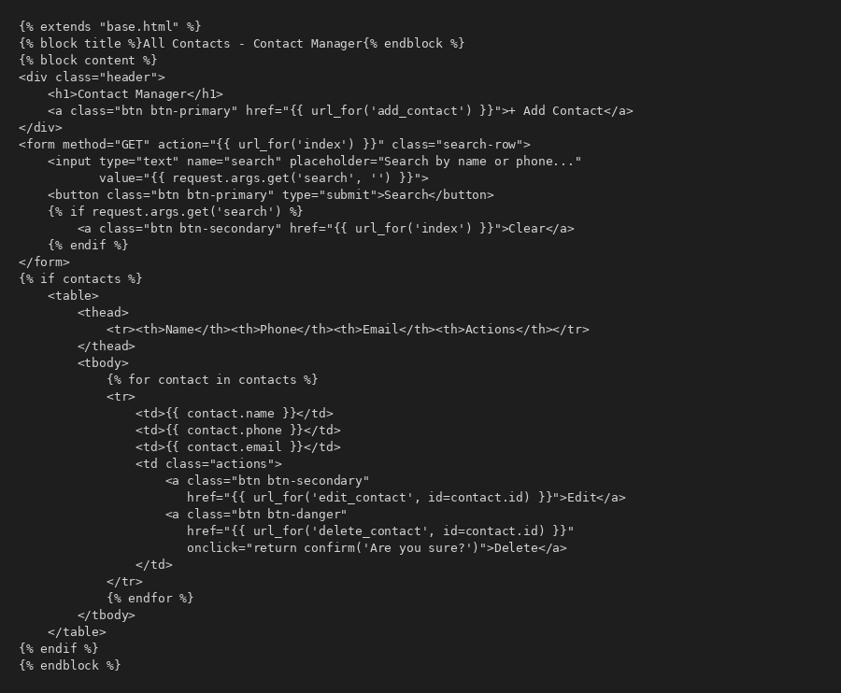

add_contact.html & edit_contact.html (Forms):

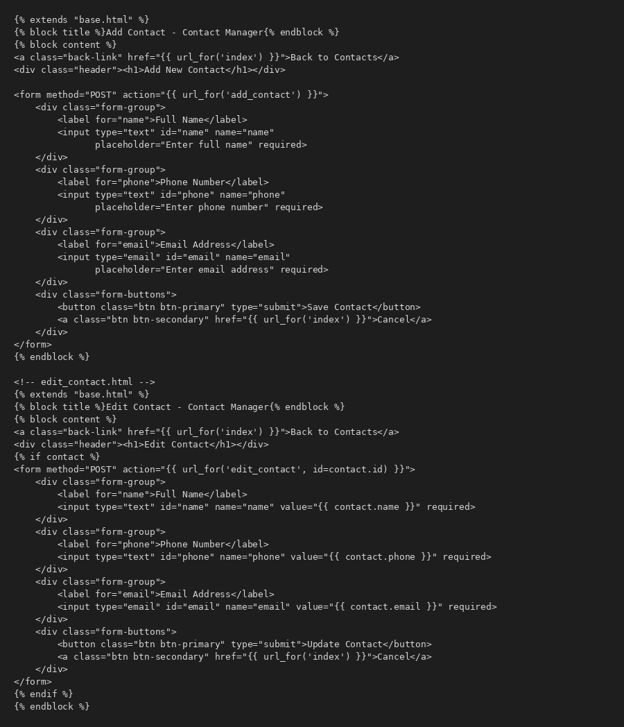

OUTPUT:

